**Database task**

**1) Select all the information about Categories.**

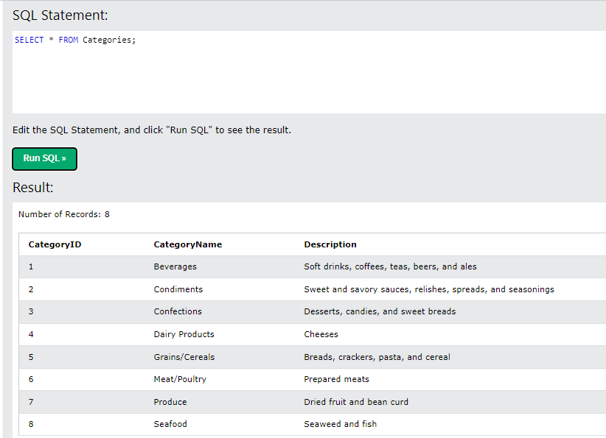

**2) Select all the information about the first 7 Customers.**

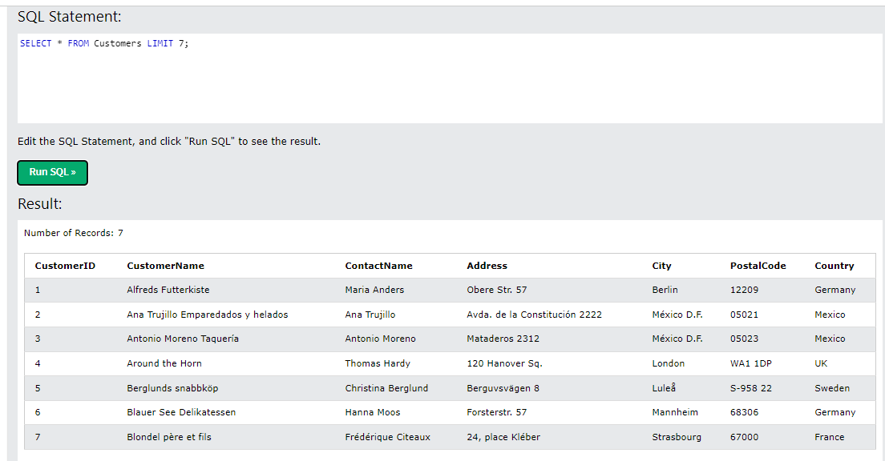

**3) Select the following information about Employee: ID, Last Name, Notes**

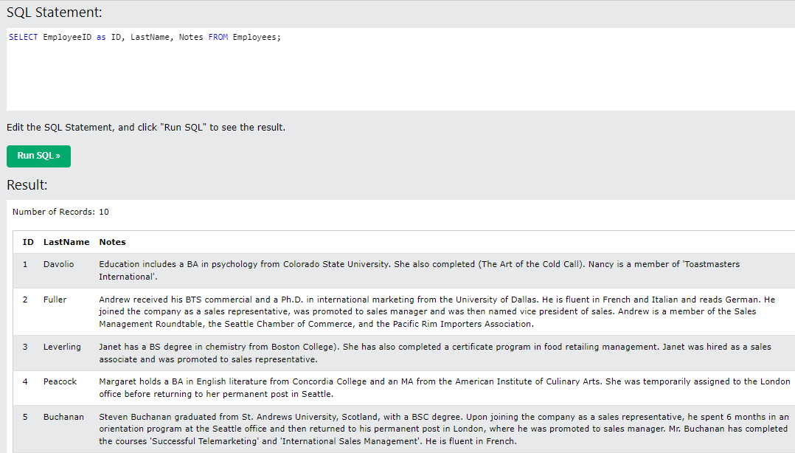

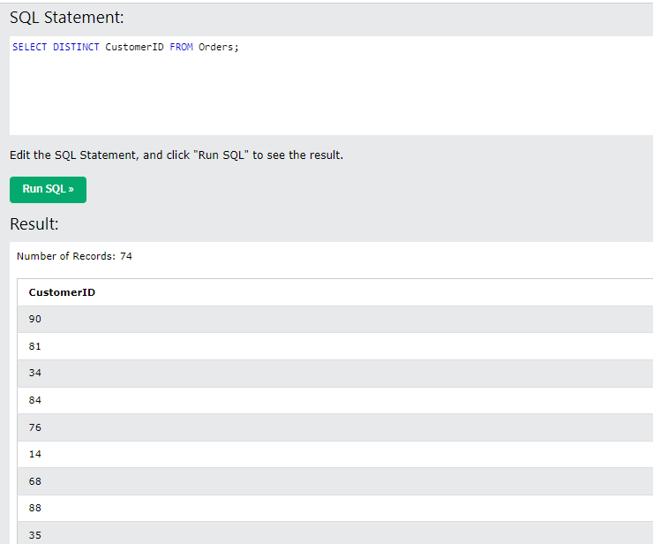**4) Select only distinct (different) Customers’ ID from Orders table**

**5) Select the information about the product names and their prices and sort them in ascending / descending orders (two separate queries).**

**in ascending order**

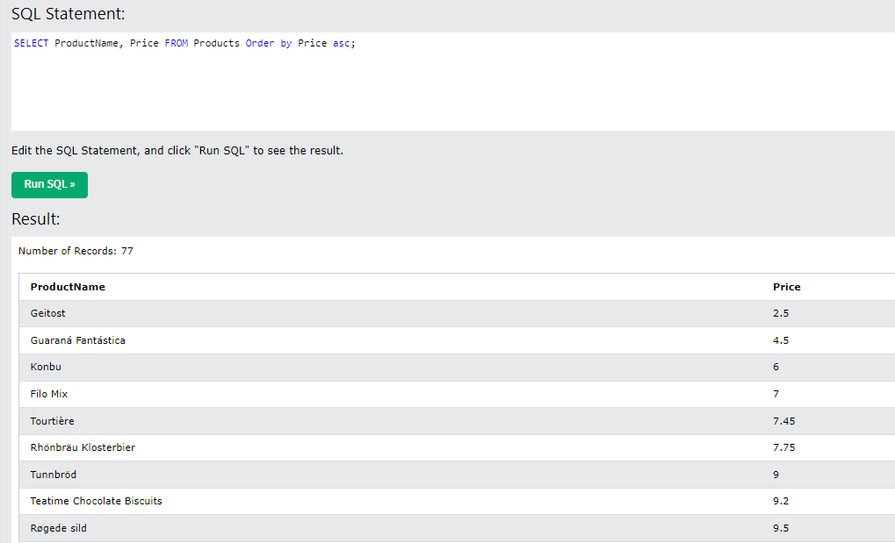

**in descending order**

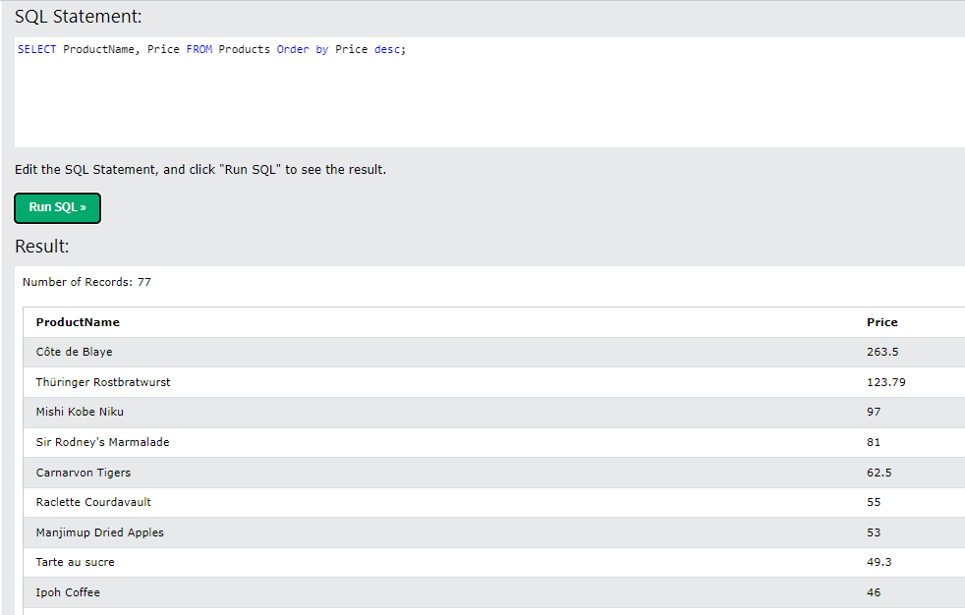

**6) Select the orders delivered the shippers with ID=3. The result should consist of 3 columns: OrderID, OrderDate and ShipperID.**

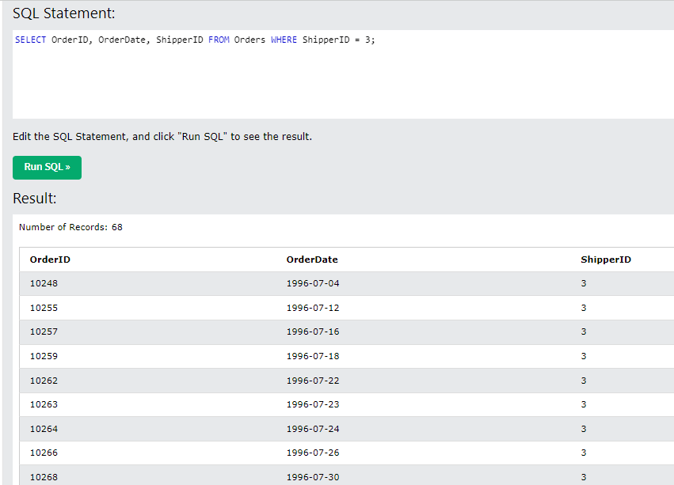

**7) Select information about the Customers whose cities are Lyon and Reims. The result should consist of 3 columns: CustomerID, CustomerName, City.**

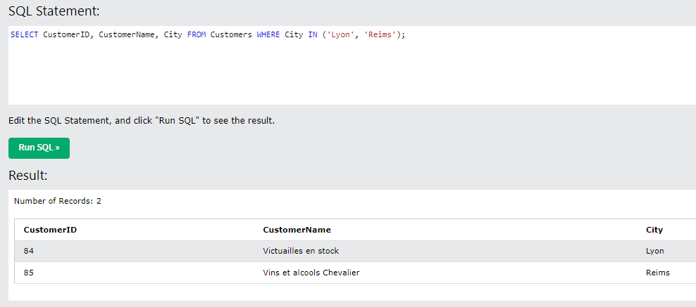

**8) Select all the information about Categories which names start with C.**

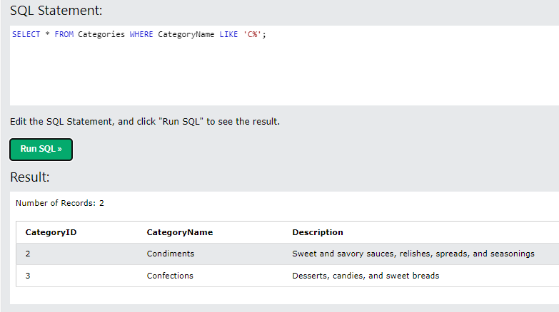

**9) Select the information about Employee whose first names contain the second ‘A’ letter. The result should consist of 3 columns: last name, first name, birthdate.**

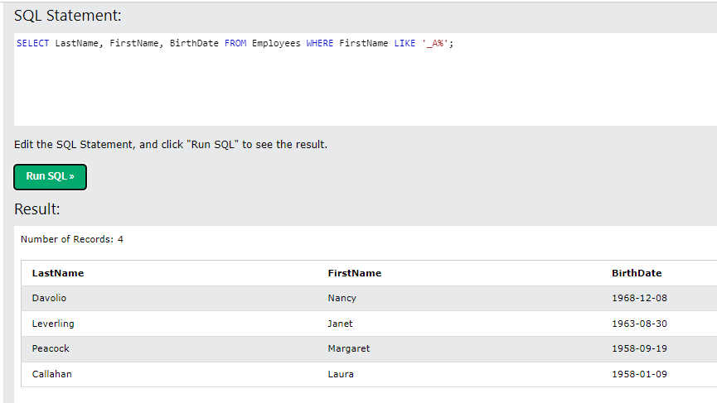

**10) Select the information about the Categories whose names DO NOT start with D**

